**MACHINE LEARNING**

**Neural Style Transfer: Creating Art with Deep Learning using tf.keras and eager execution**

Neural style transfer is an optimization technique used to take three images, a content image, a style reference image (such as an artwork by a famous painter), and the input image you want to style — and blend them together such that the input image is transformed to look like the content image, but “painted” in the style of the style image.

For example, let’s take an image of this turtle and Katsushika Hokusai’s The Great Wave off Kanagawa:

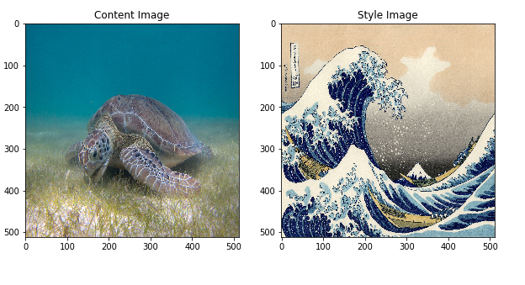

Now how would it look like if Hokusai decided to add the texture or style of his waves to the image of the turtle.

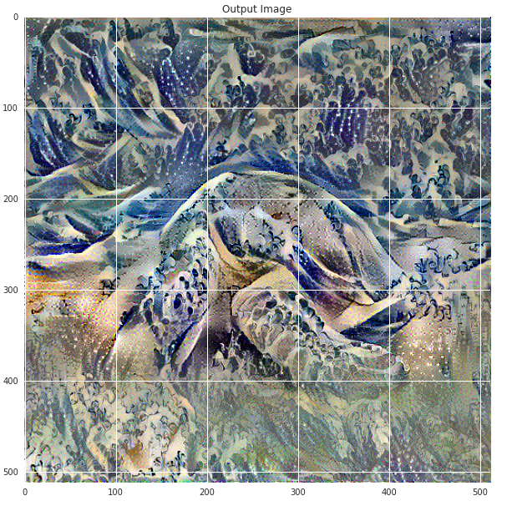

Style transfer is a fun and interesting technique that showcases the capabilities and internal representations of neural networks.

The principle of neural style transfer is to define two distance functions, one that describes how different the content of two images are, Lcontent, and one that describes the difference between the two images in terms of their style, Lstyle. Then, given three images, a desired style image, a desired content image, and the input image (initialized with the content image), we try to transform the input image to minimize the content distance with the content image and its style distance with the style image.

In summary, we’ll take the base input image, a content image that we want to match, and the style image that we want to match. We’ll transform the base input image by minimizing the content and style distances (losses) with backpropagation, creating an image that matches the content of the content image and the style of the style image.

Specific concepts that will be covered:

In the process, we will build practical experience and develop intuition around the following concepts:

* Eager Execution — use TensorFlow’s imperative programming environment that evaluates operations immediately
* Learn more about eager execution
* See it in action (many of the tutorials are runnable in Colaboratory)
* Using Functional API to define a model — we’ll build a subset of our model that will give us access to the necessary intermediate activations using the Functional API
* Leveraging feature maps of a pretrained model — Learn how to use pretrained models and their feature maps
* Create custom training loops — we’ll examine how to set up an optimizer to minimize a given loss with respect to input parameters

We will follow the general steps to perform style transfer:

* Visualize data
* Basic Preprocessing/preparing our data
* Set up loss functions
* Create model
* Optimize for loss function

Implementation

We’ll begin by enabling eager execution. Eager execution allows us to work through this technique in the clearest and most readable way.

Define content and style representations

In order to get both the content and style representations of our image, we will look at some intermediate layers within our model. Intermediate layers represent feature maps that become increasingly higher ordered as you go deeper. In this case, we are using the network architecture VGG19, a pretrained image classification network. These intermediate layers are necessary to define the representation of content and style from our images. For an input image, we will try to match the corresponding style and content target representations at these intermediate layers.

Why intermediate layers?

You may be wondering why these intermediate outputs within our pretrained image classification network allow us to define style and content representations. At a high level, this phenomenon can be explained by the fact that in order for a network to perform image classification (which our network has been trained to do), it must understand the image. This involves taking the raw image as input pixels and building an internal representation through transformations that turn the raw image pixels into a complex understanding of the features present within the image. This is also partly why convolutional neural networks are able to generalize well: they’re able to capture the invariances and defining features within classes (e.g., cats vs. dogs) that are agnostic to background noise and other nuisances. Thus, somewhere between where the raw image is fed in and the classification label is output, the model serves as a complex feature extractor; hence by accessing intermediate layers, we’re able to describe the content and style of input images.

Model

In this case, we load VGG19, and feed in our input tensor to the model. This will allow us to extract the feature maps (and subsequently the content and style representations) of the content, style, and generated images.

We use VGG19, as suggested in the paper. In addition, since VGG19 is a relatively simple model (compared with ResNet, Inception, etc) the feature maps actually work better for style transfer.

In order to access the intermediate layers corresponding to our style and content feature maps, we get the corresponding outputs by using the Keras Functional API to define our model with the desired output activations.

With the Functional API, defining a model simply involves defining the input and output: model = Model(inputs, outputs).

**Define and create our loss functions (content and style distances)**

**Content Loss:**

Our content loss definition is actually quite simple. We’ll pass the network both the desired content image and our base input image. This will return the intermediate layer outputs (from the layers defined above) from our model. Then we simply take the euclidean distance between the two intermediate representations of those images.

More formally, content loss is a function that describes the distance of content from our input image x and our content image, p . Let Cₙₙ be a pre-trained deep convolutional neural network. Again, in this case we use [VGG19](https://keras.io/applications/#vgg19). Let X be any image, then Cₙₙ(x) is the network fed by X. Let Fˡᵢⱼ(x)∈ Cₙₙ(x)and Pˡᵢⱼ(x) ∈ Cₙₙ(x) describe the respective intermediate feature representation of the network with inputs x and p at layer l . Then we describe the content distance (loss) formally as:

C:\Users\Sachin\Desktop\Dhruv\Internship\Neural Style Transfer_ Creating Art with Deep Learning using tf.keras and eager execution_files\0__xXDGQ3ZV62zte06

We perform backpropagation in the usual way such that we minimize this content loss. We thus change the initial image until it generates a similar response in a certain layer (defined in content\_layer) as the original content image.

This can be implemented quite simply. Again it will take as input the feature maps at a layer L in a network fed by x, our input image, and p, our content image, and return the content distance.

**Style Loss:**

Computing style loss is a bit more involved, but follows the same principle, this time feeding our network the base input image and the style image. However, instead of comparing the raw intermediate outputs of the base input image and the style image, we instead compare the Gram matrices of the two outputs.

Mathematically, we describe the style loss of the base input image, x, and the style image, a, as the distance between the style representation (the gram matrices) of these images. We describe the style representation of an image as the correlation between different filter responses given by the Gram matrix Gˡ, where Gˡᵢⱼ is the inner product between the vectorized feature map i and j in layer l. We can see that Gˡᵢⱼ generated over the feature map for a given image represents the correlation between feature maps i and j.

To generate a style for our base input image, we perform gradient descent from the content image to transform it into an image that matches the style representation of the original image. We do so by minimizing the mean squared distance between the feature correlation map of the style image and the input image. The contribution of each layer to the total style loss is described by

C:\Users\Sachin\Desktop\Dhruv\Internship\Neural Style Transfer_ Creating Art with Deep Learning using tf.keras and eager execution_files\0_nm5fyUiC0MK6adXL

where Gˡᵢⱼ and Aˡᵢⱼ are the respective style representation in layer l of input image x and style image a. Nl describes the number of feature maps, each of size Ml=height∗width. Thus, the total style loss across each layer is

C:\Users\Sachin\Desktop\Dhruv\Internship\Neural Style Transfer_ Creating Art with Deep Learning using tf.keras and eager execution_files\0_UTEKKzBQhN5ui46g

where we weight the contribution of each layer’s loss by some factor wl. In our case, we weight each layer equally:

C:\Users\Sachin\Desktop\Dhruv\Internship\Neural Style Transfer_ Creating Art with Deep Learning using tf.keras and eager execution_files\1_erDF2bxjJ9xKHIJ4BlzqBw.png

Run Gradient Descent

If you aren’t familiar with gradient descent/backpropagation or need a refresher, you should definitely check out this resource.

In this case, we use the Adam optimizer in order to minimize our loss. We iteratively update our output image such that it minimizes our loss: we don’t update the weights associated with our network, but instead we train our input image to minimize loss. In order to do this, we must know how we calculate our loss and gradients. Note that the L-BFGS optimizer, which if you are familiar with this algorithm is recommended, but isn’t used in this tutorial because a primary motivation behind this tutorial was to illustrate best practices with eager execution. By using Adam, we can demonstrate the autograd/gradient tape functionality with custom training loops.

Compute the loss and gradients

We’ll define a little helper function that will load our content and style image, feed them forward through our network, which will then output the content and style feature representations from our model.

Here we use **[tf.GradientTape](https://www.tensorflow.org/programmers_guide/eager" \l "computing_gradients" \t "_blank)** to compute the gradient. It allows us to take advantage of the automatic differentiation available by tracing operations for computing the gradient later. It records the operations during the forward pass and then is able to compute the gradient of our loss function with respect to our input image for the backwards pass.

Output:

